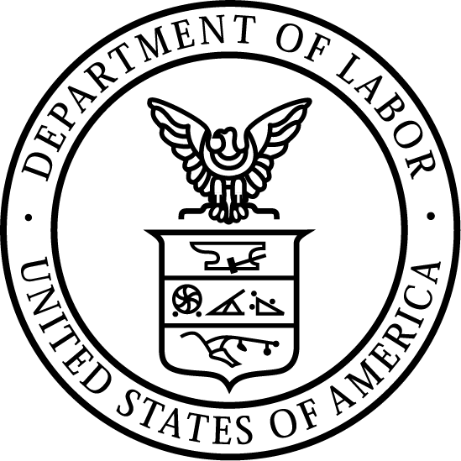
News Release
U.S. Department of Labor | March 9, 2018

U.S. Department of Labor Launches Regional Campaign In West Virginia
To Raise Awareness of Construction Industry Hazards

PHILADELPHIA, PA − The U.S. Department of Labor’s Occupational Safety and Health Administration (OSHA) has launched a regional campaign to raise awareness about the four leading safety hazards in the construction industry. The “Focus Four Hazards” campaign will serve employers and employees in Delaware, District of Columbia, Maryland, Pennsylvania, Virginia, and West Virginia.

From March through June, the campaign will educate employers to recognize, evaluate, and control electrical, struck-by, fall, and caught-in/between hazards. Each month, OSHA representatives will participate in “toolbox talk” discussions focused on one of the four hazards.

OSHA’s Charleston Area Office will work with employers throughout the state of West Virginia.

“This campaign is designed to promote and encourage a safe workplace so that employers and employees finish each day without injury,” said Richard Mendelson, OSHA Philadelphia-area Regional Administrator.

Under the Occupational Safety and Health Act of 1970, employers are responsible for providing safe and healthful workplaces for their employees. OSHA’s role is to ensure these conditions for America’s working men and women by setting and enforcing standards, and providing training, education and assistance. For more information, visit http://www.osha.gov.
# # #

Media Contacts:

Joanna Hawkins, 215-861-5101, hawkins.joanna@dol.gov
Leni Fortson, 215-861-5102, uddyback-fortson.lenore@dol.gov

Release Number: 18-337-PHI (OSHA 18-09 Focus Four Campaign – WV)

